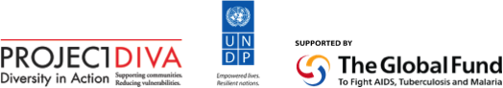

Coordinator - Terms of Reference
CCM Regional Steering Committee
Multi-Country South Asia Global Fund HV Programme (Phase 2, 2013-2015)

The Multi-Country South Asia Global Fund HIV Programme (Phase 2) is a regional HIV programme operating in eight countries: Afghanistan, Bangladesh, Bhutan, India, the Maldives, Nepal, Pakistan and Sri Lanka. The overall goal of the programme is to reduce the impact of, and vulnerability to, HIV of men who have sex with men, hijras and transgender people through Community Systems Strengthening (CSS). The United Nations Development Programme Bangkok Regional Hub (UNDP BRH) serves the role of interim Principal Recipient.

The programme supports building the capacity of in-country and regional community-based Sub-recipient organizations engaged in service provision (HIV prevention, care and support services), policy development and advocacy, partnership building with local governments and health departments, research related to MSM and transgender issues, and on creating stronger community systems to support and sustain this work. In order for the interventions carried out by the community-based organizations (CBOs) to be both effective and sustainable, it is necessary to build their capacity, create stronger linkages and networks between community organizations, community-led interventions and government, and provide longer-term support to these groups.

Recognizing that different levels and types of support are required in each country, the Principal Recipient, and two regional community networks included in this programme, the Asia Pacific Coalition on Male Sexual Health and Asia Pacific Network of People Living with HIV/AIDS, cooperate to support high-level regional and national-level policy development and advocacy, technical support and research activities. Sub-Recipients are implementing programme activities at the national and sub-national level.

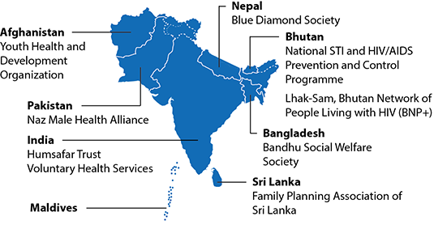

National CCMs play a key role in coordinating Global Fund supported responses to HIV at the national level and are stakeholders in the delivery of this programme. CCMs are in a unique position to identify and resolve local obstacles to effective HIV service delivery for MSM and transgender persons, policy on sexual orientation and gender identity and programme synergies between national and regional activities, and to help to ensure data, reporting and learning from programme delivery is integrated into national responses.

Thus, as per the request of Global Fund in Phase 1 of the programme, a Steering Committee was established to provide oversight of programme activities, finance, management and coordination with national CCMs in each of the eight programme countries as well as with regional programme partners.

The Country Coordinating Mechanism (CCM) Regional Steering Committee (SC) Terms of Reference articulates the rationale and roles of a supportive engagement of national CCMs under the South Asia Multi Country Global Fund HIV Programme.

To facilitate effective functioning of the CCM Regional Steering Committee, one member of the committee is to serve as Coordinator.

Role and responsibilities of the Coordinator
- Communicate with representatives from programme countries to serve as members on the CCM Regional SC.
- Maintain an up-to-date list of national CCM member contact details.
- Collate reports of national CCM members’ activities and report to the CCM Regional SC.
- In consultation with the Principal Recipient, schedule and plan CCM Regional SC Meetings.
- Promote and support agreed programme work plans within the region
- Identify opportunities for projects, activities and fundraising to support programme goals and objectives.
- Act as an ambassador for the programme, promoting awareness and support of programme goals and objectives at the regional and global levels.
- Perform any other duties as requested by the Steering Committee.

