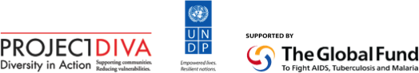

CCM Regional Steering Committee Terms of Reference
Multi-Country South Asia Global Fund HV Programme (Phase 2, 2013-2015)

The Multi-Country South Asia Global Fund HIV Programme (Phase 2) is a regional HIV programme operating in eight countries: Afghanistan, Bangladesh, Bhutan, India, the Maldives, Nepal, Pakistan and Sri Lanka. The overall goal of the programme is to reduce the impact of, and vulnerability to, HIV of men who have sex with men, hijras and transgender people through Community Systems Strengthening (CSS). The United Nations Development Programme Bangkok Regional Hub (UNDP BRH) serves the role of interim Principal Recipient.

The programme supports building the capacity of in-country and regional community-based Sub-recipient organizations engaged in service provision (HIV prevention, care and support services), policy development and advocacy, partnership building with local governments and health departments, research related to MSM and transgender issues, and on creating stronger community systems to support and sustain this work. In order for the interventions carried out by the community-based organizations (CBOs) to be both effective and sustainable, it is necessary to build their capacity, create stronger linkages and networks between community organizations, community-led interventions and government, and provide longer-term support to these groups.

Recognizing that different levels and types of support are required in each country, the Principal Recipient, and two regional community networks included in this programme, the Asia Pacific Coalition on Male Sexual Health and Asia Pacific Network of People Living with HIV/AIDS, cooperate to support high-level regional and national-level policy development and advocacy, technical support and research activities. Sub-Recipients are implementing programme activities at the national and sub-national level.

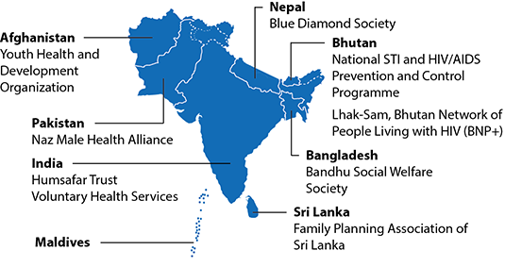

The Country Coordinating Mechanism (CCM) Regional Steering Committee Terms of Reference articulates the rationale and roles of a supportive engagement of national CCMs under the South Asia Multi Country Global Fund HIV Programme. The overall design and content of the Terms of Reference was guided by the Global Fund and determined at the South Asia GFATM Regional Programme Stakeholder Consultation held on 26-28 April 2010 in Bangkok, Thailand and the 1st CCM Steering Committee Meeting convened on June 13-14, 2011 in Colombo, Sri Lanka. The Terms of Reference has been updated following the 6th CCM Steering Committee Meeting on 23-24 June 2014, to reflect changes to the programme under Phase 2 and comments received by members of the Steering Committee.

Rationale
National CCMs play a key role in coordinating Global Fund supported responses to HIV at the national level and are stakeholders in the delivery of this programme. CCMs are in a unique position to identify and resolve local obstacles to effective HIV service delivery for MSM and transgender persons, policy on sexual orientation and gender identity and programme synergies between national and regional activities, and to help to ensure data, reporting and learning from programme delivery is integrated into national responses.

As per the request of Global Fund in Phase 1 of the programme, a Steering Committee was established. According to the agreement, the Steering Committee is to be composed of a civil society and government representative of the CCM of each of Afghanistan, Bangladesh, Bhutan, India, Nepal, Pakistan and Sri Lanka. Throughout the term of the programme, the Principal Recipient will provide evidence that the Steering Committee has conducted meetings on a bi-annual basis to review the programmatic, financial and managerial status of the programme. In Phase 2 of the programme, with UNDP BRH now in the position of Principal Recipient, the same practices will be adhered to.

Steering Committee Objectives
- Provide oversight of programme activities, finance, management and coordination with national CCMs in each of the eight programme countries as well as with regional programme partners. This will be aided by establishment of technical focal points among the members on each of these core areas.
- Facilitate communication between national CCMs and regional programme partners
- Provide quarterly, programme updates to enable national CCMs to identify and resolve local implementation obstacles, and coordinate policy/programme synergies between national and regional activities
- Maintain transparency and coordination with national and country-level Global Fund programmes

To achieve these agreed objectives, the programme CCM Steering Committee partners commit to the following:

Country Coordinating Mechanisms (CCMs)
- Receive regular updates from the regional Principal Recipient
- Provide updates on the regional programme to national CCM at regularly scheduled national CCM meetings, and share meeting minutes or copies of presentations given with the PR.
- Invite national SR to give update at regularly scheduled CCM meeting.
- Nominate one government and one civil society representative to attend regional bi-annual CCM Steering Committee meetings
- Conduct periodic oversight site visits to programme sub-recipients and activities.
- Recommend alignment of regional and country level programming

UNDP BRH
- Submit regular updates on the programme to the CCMs
- Maintain consistent communication with CCMs, for example through monthly calendar of event and quarterly newsletter emails.
- Convene two regional Stakeholder Consultations annually, in cooperation with regional sub-recipient APCOM.
- Provide MSM and HIV programming resource persons for CCM SC meeting
- Provide technical support to country partners who attend and participate in national CCMs
- Identify synergies and opportunities for programming to catalyze regional and country-level activity on MSM, TG and HIV-related programming
- Coordinate with other donors and development partners to forge strategic partnerships, seek opportunities for collaboration and ensure avoidance of duplication and overlap
- Suggest new interventions and reprograming of funds for priority areas in programme countries
- Follow up on recommendations of the CCM SC.
- Update CCM SC on recent communications from the Global Fund and upcoming changes to the programme which may affect implementation.

Sub-Recipients
- Provide updates on the regional programme at national CCM meetings
- Provide updates at the CCM Regional Steering Committee meeting on programme activities
- Advise the CCM SC of any policy, legal environment or epidemiological changes that could affect programme implementation

