Funding Request Form
Allocation Period 2020-2022
Tailored for National Strategic Plans (NSPs)

Refer to the “Tailored for National Strategic Plans (NSPs)” Instructions to complete this form.

Summary Information
Country(s) | Bangladesh
Component(s) | Tuberculosis
Planned grant(s) start date(s) | 1 January 2021
Planned grant(s) end date(s) | 31 December 2023
Principal Recipient(s) | External Resource Division (ERD), MoF& BRAC
Currency | USD
Allocation Funding Request Amount | 115.067.401
Prioritized Above Allocation Request (PAAR) Amount
Matching Funds Request Amount  (if applicable) | 10,000,000

Section 1: Context Related to the Funding Request

To respond to the questions below, refer to the Instructions, NSPs, other national documents, and the Essential Data Table(s).

Context Included in NSPs and Other Reference Documents

Check relevant contextual areas included in NSPs, as applicable. For areas not included in NSPs, provide reference to other relevant document(s) with respective page numbers or provide a narrative in Section 1.2.

Key area | Check the box if in NSP | Relevant section(s) and/or page(s) in NSP | If not in NSP, refer to another document (specifying page numbers) or refer to Section 1.2
Cross-cutting
Health system overview | ☒ | 3.1
Health sector strategy | ☐ |  | 4th HEALTH, POPULATION AND NUTRITION SECTOR PROGRAM,  January 2017 - June 2022, Ministry of Health and Family Welfare, Government of the People’s Republic of Bangladesh
Community responses and systems | ☒ | 8.1.6
Role of the private sector | ☒ | 3.2 & 8.1.16
Human rights-related barriers/inequities in access to health services | ☒ | 8.1.15
Gender and age-related barriers/inequities in access to health services | ☒ | 8.1.6
Economic, geographic and other barriers/inequities in access to health services | ☒ | 4.1
Role of community groups in the design and delivery of programs | ☒ | 8.1.6
Linkage between disease specific NSPs and sector strategies | ☒ | 5
Other | ☐
Disease-specific
Key stakeholders of NSPs and operational plan development | ☒ | 3.2 & 3.4.1
Epidemiological profile | ☒ | 4
Analysis of key, vulnerable and/or underserved populations | ☒ | 4.7
Lessons learned from past program implementations | ☒ | 6.10
Disease-specific national policies and guidelines | ☒ | 8
Summary budget, including costing methodology and assumptions | ☒ | 9
Program’s prioritization approach | ☒ | 6
Monitoring & evaluation plan | ☒ | 8.5.1& 8.5.2
Operational plans | ☒ | 10
Other | ☐

Contextual Information not Included in NSPs

For the gaps in question 1.1, provide information below.

[Applicant response]

Section 2: Funding Request and Prioritization

To respond to the questions below, refer to the Instructions, NSPs, Programmatic Gap Table(s), Funding Landscape Table(s), Performance Framework, Budget and Essential Data Table(s). Include narrative only if these documents omit required information.

Overview of NSP Strategic Areas

Complete the table below, referring to the relevant NSP page numbers, whenever possible. Ensure information is consistent with NSP cost details and analysis provided in Funding Landscape Table(s).

NSP strategic areas | Key interventions  (refer to NSP page numbers) | Baseline and targets  (refer to NSP page numbers) | NSP funding need  In the grant currency for implementation period of this funding request | Anticipated funding gap as % of need  for implementation period of this funding request  (before Global Fund contribution)
Case finding, diagnosis and treatment of non-MDR, adult cases | Summary (page 53-54)  Details (page 53-68) | Page 48, 49 | $ 277,576,721 | 51%
Case finding, diagnosis and treatment of Childhood TB cases | Summary (page 50)  Details (page 68-72) | Page 50 | $ 5,861,070 | 77%
Provision of preventive treatment to risk groups and infection control activities | Summary (page 51)  Details (page 73-75) | Page 51 | $ 57,147,096 | 63%
Case finding, diagnosis and treatment of MDR-TB cases | Summary (page 51)  Details (page 75-78) | Page 51 | $ 41,644,065 | 48%
Addresssing health care system bottlenecks | Summary (page 52)  Details (page 78-89) | Page 52 | $ 147,337,836 | 14%
Support for operational research to foster innovation | Summary (page 53)  Details (page 91) | Page 53 | $ 5,681,019 | 96%
Add rows as relevant
TOTAL AMOUNT |  |  | $ 535,247,809 | 42%

Funding Request to the Global Fund

Fill in questions a) and/or b) as relevant for your country funding request approach(es):
a) for funding requests using the traditional, Performance Based Funding approach
b) for funding requests using the Payment for Results modality

All applicants should fill in questions c), d) and e).

- For a funding request using the Performance Based Funding approach:
Use the table below to list and provide the rationale for each intervention prioritized for Global Fund funding.

COMPONENT: (Indicate component here.)

NSP Strategic Area #: Case finding, diagnosis and treatment of non-MDR, adult cases
Intervention | Rationale for prioritization for Global Fund funding | Amount requested  from the Global Fund
Countrywide expansion of the new diagnostic algorithm | During the previous funding cycle, the NTP Bangladesh has introduced a new diagnostic algorithm based on current WHO recommendations actively promoting the use of revised screening algorithms to increase TB case detection. During 2019, the performance of the new diagnostic algorithm was evaluated by the NTP. Based on the evaluation, a decision on further scale-up of the algorithm was made. The NTP plans to achieve countrywide implementation of the new diagnostic algorithm during 2021-2025. | $ 76.941
Design and implementation of activities to increase case finding among specific high-risk areas or population groups | During the previous funding cycle, the NTP Bangladesh has conducted active case finding activities in high-risk groups based on WHO recommendations as an effective means towards increasing case detection . A mapping and situation analysis of these populations will be required, and successful models of screening, referral, diagnosis, and treatment will be standardized as NTP policies and expanded to cover high-risk populations across the whole country. Successful approaches will be expanded to hard to reach areas like Char , hill tract areas, tea garden, prisons, slums, areas with high migratory populations, and other high risk groups (diabetics, miners and other workers intensely exposed to dust, workplace- areas with high concentrations of informal sector workers) to increase case notifications. Attention to gender will be important element in the models. Rural issues will be analyzed given the particular challenges for both diagnosis and DOT due to fewer community health resources. | $ 519.523
Ensure full implementation of WHO’s TB-HIV policy | Addressing the threat of TB/HIV co-infection is a priority activity for the NTP Bangladesh. Under this strategy, the full package of WHO’s TB-HIV strategy will be implemented, including stronger TB/HIV collaboration between the NTP and NASP with coordinated guideline writing and biannual TB/HIV collaborative meetings; HIV screening for all newly-diagnosed TB cases; introduction of “provider initiated HIV testing” for DOTS clinics, hospitals, and areas with high number of TB patients with HIV risk and the screening of all HIV patients for symptoms of TB. | $ 27.388
Ensure regular maintenance of all diagnostic equipment | Advanced diagnostic technologies such as gene Xpert or LED microscopy require the ensured regular maintenance of all equipment for diagnostic accuracy. Under this strategy, the maintenance of advanced equipment will be ensured through the establishment of equipment maintenance/repair contracts at the time of purchase. | $ 128.135
Ensure regular supervision of all patient support providers | The provision of patient support through multiple providers including family members is a core strategy ensuring continued high treatment success rates. The regular supervision of all patient support providers is mandatory to ensure the reliable provision of DOT as well as appropriate management of side effects. Under this strategy, a regular schedule of supervision activities to all patient support providers will be established in collaboration between the NTP and NGO partners. The strategy will also ensure the documented feed-back on supervision activities and follow up to ensure that corrective actions are being taken on identified problems. | $ 1.791.554
Ensure the availability of functioning X-ray facilities at all CDCs, CDHs and Upzillas | The new diagnostic algorithm includes a much broader use of initial chest X-ray examination for all suspects. Under this strategy, the availability of functioning X-ray facilities at all CDCs and CDHs will be ensured through the repair/maintenance of existing machines. | $ 889.599
Ensure the implementation of contact screening procedures at all facilities | The screening of contacts of active TB cases for symptoms of TB is an important tool to increase case detection. While the new NTP Manual contains detailed instructions on the implementation of this method, the policies are rarely effectively implemented. This strategy will focus on the development of clear-cut operational guidelines and plans for implementation & monitoring, followed by training of all staff in contact tracing techniques, as well as the strengthening of supervision for this program component. In addition, local NGOs/CBOs will be mobilized through small implementation schemes. | $2.893.066
Expansion of Gene Xpert sites to cover all upazillas and large public/private hospitals by 2025 | The NTP prioritized this intervention in the NSP 2021-2025, with the aim of achieving countrywide access to Gene Xpert testing by 2025. Total country need will be 1,260 machines.  During the FR period, the purchase of 180 new Gene Xpert in addition to the 470 existing machines (as of 2020) is planned, for a total of 650 machines by 2023. | $36.113.541
Expansion of successful case-finding activities at community level | Community-based case finding activities have been very in successful in increasing case detection in some areas during the previous funding cycle. Under this strategy, successful models of community-based case finding activities will be expanded to all divisions and districts in the country. The NTP, in collaboration with NGO partners, will develop standard models describing logistics and staffing requirements based on the diversity of the types of client, providers and facilities. The equal / proportionate distribution of community volunteer or DOT Providers in the areas of urban and metropolitan cities including rural areas will be ensured. | $34.244.524
Implement a comprehensive advocacy and communication strategy | Effective advocacy and communication interventions are of key importance to further increase case detection. Under this strategy, a revised plan for advocacy and communication will be completed and circulated to all stakeholders. The strategy will have the general Objective to create mass awareness and sensitization among stakeholders of National TB control Programme at all levels. Specific Objectives will be:  - To ensure enabling policy environment towards achieving multi-sectoral response on TB  - To create greater awareness on TB Diagnosis, Treatment and Prevention at National Scale in order to enhance people’s access to TB information and services  - To strengthen engagement of all health authorities and service providers of public and private health care including formal / non-formal service providers  - To enhance empowerment of people with TB and their communities  - To contribute to strengthening of health systems  - To enhance collaboration of GO/NGO stakeholders  - To enhance collaboration with diagnostic network | $ 51,887
Strengthen the engagement of private providers in TB control activities | Public-private mix (PPM), or the involvement of all care providers, is particularly important in Bangladesh, where a large proportion of presumptive TB cases seek care first to the private sector. There are more than 90,000 registered physicians in Bangladesh, 53% (approx.) of whom operate exclusively in the private sector. Current examples of collaboration include the SMC model, which engages blue star and green star pharmacy (aka. drug selling) outlets and call center (tele jiggasa).  This strategy involves a review of all existing PPM models in different settings and identification of the model for scale up/ Identify new model (year 1), the scale up of models ( year 2 and 3), the provision of NTP drug supply through the private providers (formal and informal) and supportive supervision, monitoring and recording and reporting both at central and peripheral levels. | $4.603.558
Workforce development | The NTP is overall responsible for training of all categories of health workers (medical doctors, nurses, laboratory technicians, paramedical staff, field-level staff, community health workers and volunteers, NGO staff, corporate sector health workforce, graduate and non-graduate private practitioners) at all service delivery levels. Partners can be involved based on their comparative advantage.  In-service training programmes for different categories of health workers involved in the implementation of NTP activities will be updated to include new developments in different components of TB control. A comprehensive training package will be developed to strengthen the involvement of strategic partners. | $2.722.105
Add rows as relevant

NSP Strategic Area #: Case finding, diagnosis and treatment of Childhood TB cases
Intervention | Rationale for prioritization for Global Fund funding | Amount requested  from the Global Fund
Improved documentation and data management | Aligning with the NTP vision on technology utilisation, the current paper-based CI approaches will be transitioned to digital platforms, such as eTB Manager and the mobile applications developed under Challenge TB. Children identified with presumptive TB at facilities and during CI will be notified to the local basic management units (BMUs), linked to local DOTs centres and engaged with DOT providers. Central data personnel will analyse the process of CI, notification and treatment outcomes to inform national policy. All of this will make child TB more visible for appropriate interventions. | $30.706
Intensify facility based active case finding (ACF) among all children and adolescents with special attention to under-5s | Facility-based ACF has resulted in detection of large numbers of children with TB across South Asia (Nepal, India, Pakistan) and most recently in Bangladesh. ACF will involve screening for TB in all children seeking medical care in busy health facilities with daily sick child attendance exceeding 50. Lessons learned from CTB’s ACF of children will guide design including the use of screening techniques in busy OPD waiting rooms and other high risk groups including in-patients. | $846.999
Strengthen community-based Contact Investigations (especially Home Contact Management [HCM]) | To reduce the burden of childhood tuberculosis disease and death, more children with tuberculosis need to be diagnosed and treated or prevented from becoming sick with tuberculosis in the first place. Preventing cases of tuberculosis is especially important in resource-limited settings, where the diagnosis of children with tuberculosis can be particularly challenging. The 2016 CI SOP under NTP stewardship, which has not been implemented, needs to be updated and rolled out across the country.  To begin the process, a three-month preliminary landscape analysis and baseline assessment of the CI scenario in rural and urban areas will be carried out to design a realistic CI programme. This will be in consultation with district (Civil Surgeons), upazila (UHFPOs) health managers as well as Chief Medical Officers in city corporation/municipalities. CI training will then be undertaken, and activities rolled out. Lessons learnt in the first year will inform further expansion in years two to three. | $96.254
Add rows as relevant

NSP Strategic Area #: Provision of preventive treatment to risk groups and infection control activities
Intervention | Rationale for prioritization for Global Fund funding | Amount requested  from the Global Fund
Countrywide implementation of a strategy for treatment of latent tuberculosis infection (LTBI) | Based on recommendations published in recently updated WHO guidelines on LTBI, the NTP considers the following populations to be at-risk populations that should receive LTBI treatment:  - Adults, adolescents, children and infants living with HIV  - HIV-negative household contacts  - HIV-negative children aged < 5 years who are household contacts of people with bacteriologically confirmed pulmonary TB and who are found not to have active TB on clinical evaluation should be given TB preventive treatment.  - Children aged ≥ 5 years, adolescents and adults who are household contacts of people with bacteriologically confirmed pulmonary TB who are found not to have active TB by clinical evaluation may be given TB preventive treatment.  Detailed SOPs for the introduction of LTBI will be developed by the NTP in early 2020. The strategy will involve the identification of focal persons for programmatic management of LTBI in the field, capacity development of Focal persons to manage LTBI, and the development of a working group in every treatment centre of LTBI involving GOB and implementing partners. The strategy will also involve the development of an ACSM plan and follow-up and monitoring activities for LTBI management. | - $6.793.092
Implement a comprehensive infection control policy at all implementation sites | The NTP has developed a comprehensive infection control policy, but implementation at peripheral facilities has been limited. Under this strategy, the implementation of infection control at all treatment facilities will be ensured through reconstitution of the multidisciplinary team on TB IC policies and guidelines, and inclusion of their oversight in the scaling-up of TB IC; development and implementation of a program for pre-service and in-services TB screening, including routine surveillance among HCW and laboratory staff; definition of a set of SOPs for waste management for each level of care; training of Master Trainers and managers responsible for regular supervision and M&E on technical and programmatic aspects of TB IC. | 1.027.678
Add rows as relevant

NSP Strategic Area #: Case finding, diagnosis and treatment of MDR-TB cases
Intervention | Rationale for prioritization for Global Fund funding | Amount requested  from the Global Fund
Continue social support policies for MDR−TB patients and incentive package for MDR−TB DOT Providers across all sites in the country. | Social support mechanisms for MDR-TB patients, as well as financial incentives for MDR-TB DOT providers have been very effective in ensuring treatment success. Under this strategy, successful models of patient support and incentives for treatment supporters will be continued. | $2.962.941
Ensure adequate diagnosis of patients with presumptive MDR TB at all NTP facilities | The adequate diagnosis of MDR TB presumptives will require adequate history taking by all TB care providers and access to gene Xpert at all facilities. Under this strategy, the training of TB care providers will be intensified to ensure adequate history taking of previous TB treatment and subsequent correct classification of patients by health care providers. | $987.379
Ensure adequate management of drug side effects (aDSM) under MDR TB treatment | To improve the management of adverse effects a number of system strengthening initiatives and protocols are to be implemented:  1. The implementation of an initial enrollment intake form with a monthly encounter paper-based form (this form can also be in electronic format).  2. Improvements to the monitoring of smears and cultures while on treatment through inclusion of an MDR-TB module in eTB Manager  3. Monthly monitoring of potassium and creatinine while on the injectable agent. Replacement of potassium (and magnesium) as needed.  4. TSH monitoring every three months at minimum for signs of hypothyroidism in patients taking both PAS and ethionamide. Patients receiving only ethionamide can have their TSH checked every six months.  5. Baseline and immediate audiometry implementation for all patients with hearing loss.  6. Provision of ancillary medicines at no cost to all MDR-TB patients  7. The measurement of BMI at the start of treatment to calculate and monitor nutritional status and support as needed.  8. Provision of home-based care, counseling & support services by involving local/grass-root level NGO/CBO partners  9. Reporting to the national level will be ensured and a system will be developed for systematic reporting to DRAP analysis and review of data to influence policy changes where necessary | $379.299
Ensure fully functional RTRLs | Access to drug sensitivity testing for first- and second-line resistance is a key requirement for successful implementation of the MDR-TB strategy. This strategy will ensure that all RTRL offer the full range of diagnostic services, including solid and liquid culture, 1st/2nd line LPA and DST. | $91.627
Introduction of a fully oral MDR-TB treatment regimen | The NTP has updated the RR/MDR TB regimens for Bangladesh based on the recommendations in WHO’s 2019 DR-TB guideline, which include recommendations for the use of fully oral regimens.  Shorter, all-oral regimen will be used for routine use (and this would be the main regimen for majority of the patients). The NTP plans to use the fully oral regimens for 100% for MDR-TB patients by 2025. | $12.370.239
Provide palliative care for patients without further treatment options | The NTP will ensure the provision of palliative care as well as social support for all patients who will not respond to either the MDR TB or XDR TB treatment regimen. | $7.788
Add rows as relevant

NSP Strategic Area #: Addresssing health care system bottlenecks
Intervention | Rationale for prioritization for Global Fund funding | Amount requested  from the Global Fund
Build, maintain and update Infrastructure for quality TB care (new construction , upgradation and maintenance) | Well functioning infrastructure is a key requirement for successful program implementation. This strategy seeks to ensure full operationalization and utilization of all health facilities.  The total NSP budget for this component is USD 32.1 Million, of which the GOB will cover 30.1 Million. GF support is sought to address some remaining fundig gaps. | $617.882
Capacity building on PSM both in core PSM personnel as well as other related (especially at field level) | this intervention seeks to improve capacity and leadership role of the central logistics team in the management of logistics/supply chain issues at lower levels and to mitigate gaps in knowledge, skills, practice of the field staff involved in logistics/supply management (store keepers, TLCA, PO). Capacity building interventions like training and supportive supervision are a key component. | $356.812
Improve Financial Capacity ensuring sustained resources for National TB Program Management | This intervention aims to achieve efficiency gains through improved budget management and increase fund absorption capacity, which in turn can yield additional financial resources to benefit the program. | $56.706
Integration of TB data within Robust National Information System | In Bangladesh, 4th SWAp of MOHFW under 7th Five year prioritized to build a robust National Information System for routine data generation, analysis, interpretation, review and action. It further aimed to support the SDGs’ annual global reporting to keep track on national progress of SDGs inclusive of health related SDGs. For this, the MIS- DGHS already developed a prototype of National Health Information System to ensure effective use by all program under a data driven evidence generation and decision making policy framework. TB data management system has also been considered for transfer to DHIS2, but 100 % coverage yet not established due to gaps in capacity and other system constraints.  This intervention seeks to ensure 100% implementation of DHIS2 for TB data management. | $54.569
Maximize Capacity and Efficiency of Health Workforce for integrated TB care | The Bangladesh Health Care System in pluralistic in that a publicly financed health service delivery system co-exists with a privately financed health market which include the private health care system and an NGO health service delivery system. 8th JMM recommended that the role of NGOs can be re-examined and shift to fit within the public health care system to increase the service effectiveness and efficiency of GoB to undertake responsibility to sustain TB diagnosis, care and prevention under the leadership of GoB. This strategy will implement a new service integration model that will improve program efficiency through more effective collaboration with other disease programs as well as better integration of all partner activities in TB control.  Implementation of this strategy will be based on a phased approach which will ensure effective implementation of NTP activities at all sites during the transition period. | $10.715.010
Promote a Rights-Based Approach to TB care and Prevention engaging relevant Stakeholders, Civil Societies and Affected Communities | Taking into account, among others things, the SDG Goal 2030, Political declaration of UNHLM and Stop TB partnership Global Plan to end TB and WHO End TB Strategy, the NSP 2021- 2025 prioritized a new focus to establish the protection and promotion of human rights, ethics and equity, as well as strong coalitions with civil society organizations and communities, as fundamental principles essential to the tuberculosis response.  This intervention seeks to implement this strategy through a comprehensive set of workshop, training and other community engagement activities.. | $24.265
Repair, maintenance and procurement of IT, diagnostic and other fixed assets/equipment | To expand the accessibility of the service and ensure continuity by keeping the tools functional, procurement and repair/maintenance is a pre-requisite.  - In coordination with relevant MOH departments, this strategy seeks to ensure effective infrastructure through procurement plans taking into account life cycle and warranty issues and ensuring regular servicing and repair/maintenance. | $216.287
Strengthen partnership and coordination mechanisms for sustained TB Care | Bangladesh was represented at the Moscow Ministerial meeting on TB that was held in November 2017 and was a signatory to the Ministerial Declaration that came out of this meeting in which countries committed to accelerate action to end TB to meet the milestones towards achieving the SDGs. An important outcome of this meeting was the commitment by countries to pursue a multi – sectoral approach with engagement of Government at the highest possible level to the fight against TB. This strategy will ensure the effective implementation of a multisectoral accountability framework for TB (MAF-TB). | $2,995,802
Sustained push for multi-sectorial collaboration and coordination mechanism, securing high level policy support | The 4th Health, Population and Nutrition Sector Programme (2017-2022), provides a coherent vision for the Health Sector and clearly describes the needs. It includes a well thought out essential service package and has defined impact goals. Tuberculosis is included among the 29 operational programmes in the 4th HPNSP.  Government of Bangladesh is such committed to achieve the global commitment and in light with this NSP 2021-2025 prioritizing focus for establishing a multisectoral accountability framework for TB by engaging high level ministry , WHO and other development partners and affected community. This will be a customized framework for Bangladesh in collaboration with WHO. | $374.245
Add rows as relevant

(Add additional tables as relevant)
TOTAL AMOUNT requested from the Global Fund | $125.067.401

Explain the prioritization approach used to select interventions for Global Fund funding.

The funding request was prepared on the basis of the recently developed National Strategic Plan for TB Control (NSP) 2021-2025. The NSP, in turn, was developed in line with WHO’s End TB Strategy. Building on the Strategy’s Three Pillars (I. INTEGRATED, PATIENT-CENTRED CARE AND PREVENTION; II. BOLD POLICIES AND SUPPORTIVE SYSTEMS; III. INTENSIFIED RESEARCH AND INNOVATION) and following the key principles of government stewardship and accountability, strong coalition with civil society organizations and communities, protection and promotion of human rights, ethics and equity, and adaptation of the strategy and targets at country level, the NSP describes key interventions and activities that will enable the NTP to achieve the End TB Strategy’s Milestones for 2025 (75% reduction in tuberculosis deaths and 50% reduction in tuberculosis incidence rate) and targets for 2035 (95% reduction in tuberculosis deaths and 90% reduction in tuberculosis incidence rate).The NSP also accounts for the UN High Level Meeting (UNHLM) targets. Of key importance for the development of the NSP as well as the preparation of the funding proposal was an assessment of the potential impact of alternative interventions, The potential impact of NSP interventions has been assessed using a recently developed dynamical model of TB transmission specifically addressing the situation in SEARO countries. In high-level summary, the model explicitly captures the national TB programme (NTP) and non-NTP sectors, and the respective standard of TB care in these sectors. In doing so, the model also captures the implications of diagnostic delays and treatment outcomes, for overall transmission. For simplicity, the model does not distinguish age groups and is nationally aggregated. However, it incorporates HIV/TB co-infection, as well as ‘risk groups’ bearing a disproportionate TB burden, and the generation and transmission of drug-resistant TB (DR-TB). The modeling results showed that in order to achieve the End TB Strategy’s target of a 50% incidence reduction by 2025, it will be crucial to increase the case detection ratio (CDR) to more than 90% by 2020.
The impact of the planned NSP activities on incidence is summarized in the graph below, showing that NSP activities would result in a decrease of incidence of >50% by 2025.
Expected impact of NSP activities on TB incidence, 2018-2025
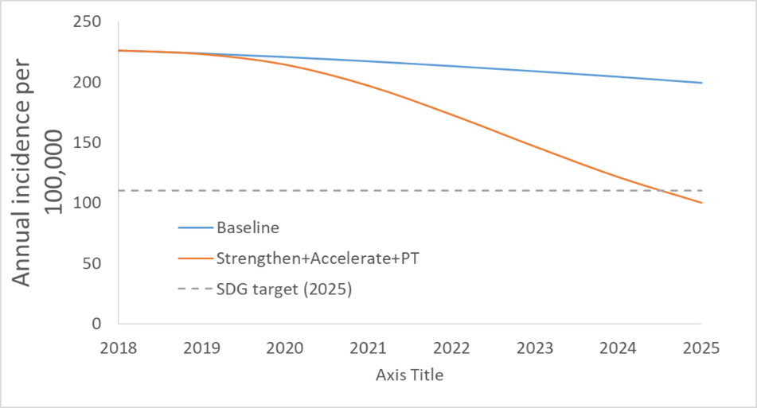

The impact of the planned NSP activities on mortality is summarized in the graph below, showing that NSP activities would result in a decrease of mortality of >75% by 2025.

Expected impact of NSP activities on mortality, 2018-2025
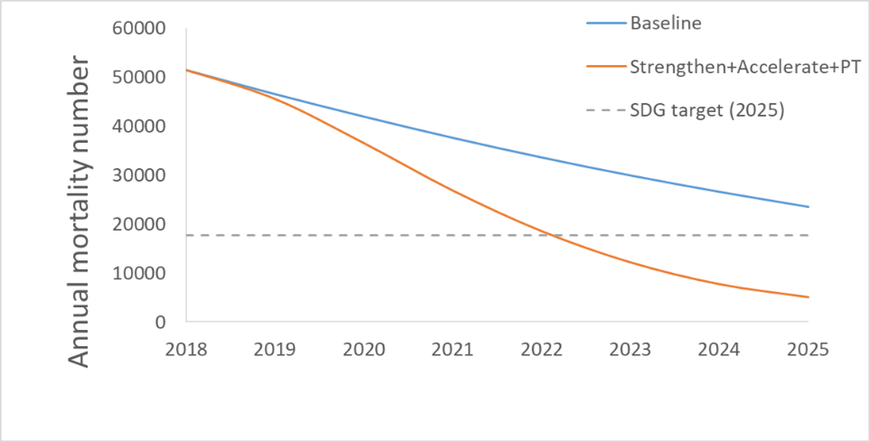
.
The development of the NSP and consecutively the allocation funding proposal was guided by the principle of investing available resources in those interventions that will achieve maximum impact. Based on internationally accepted principles as formulated in WHO's TB policy documents, maximum impact for TB control is expected from interventions that either increase case detection (for both drug-sensitive and MDR-TB cases) or improve treatment outcomes for detected cases. Over the previous years, the NTP has been very successful in establishing treatment services that assure very high treatment success rates for detected cases, regularly exceeding 90% for smear-positive cases. The further improvement of treatment outcomes was therefore not of primary concern for the development of the funding proposal.

b) If an aspect (or the entirety) of this funding request uses the Payment for Results modality:

Use the table below to list and provide the rationale for selection of the proposed performance indicators or milestones for Global Fund funding.

Performance indicator or milestone | Target |  |  |  | Rationale for selection  of the indicator/milestone
 | Baseline | Y1 | Y2 | Y3
Add rows as relevant
TOTAL AMOUNT requested from the Global Fund

Specify how the accuracy and reliability of the reported results will be ensured.

[Applicant response]

Explain the prioritization approach used to select performance indicators and/or milestones as results for Global Fund funding.

- Opportunities for integration: explain how the proposed investments take into consideration:
- Needs across the three diseases and other related health programs;
- Links with the broader health systems to improve disease outcomes, efficiency and program sustainability.

In Bangladesh, achievement in the Health Sector do not solely result from MOHFW’s success; the other sectors like information, education, social welfare and agriculture etc. also contribute enormously. Therefore in 4th HPNSP , MOHFW aim to work closely with others sector to achieve the HNP related SDG Targets. For TB, to address the issues that affect access to health care, impact nutritional status, health related catastrophic cost , to overcome social barrier and stigma related TB , concerned effort and actions across the multiple sector will be taken.
Bangladesh was represented at the Moscow Ministerial meeting on TB that was held in November 2017 and was a signatory to the Ministerial Declaration that came out of this meeting in which countries committed to accelerate action to end TB to meet the milestones towards achieving the SDGs. An important outcome of this meeting was the commitment by countries to pursue a multi – sectoral approach with engagement of Government at the highest possible level to the fight against TB. The People’s Republic of Bangladesh was also represented at the first ever United Nations General Assembly Meeting on TB (TB-UNHLM) in which a number of commitments were made by Heads of States and Governments to fight TB including the adoption of very ambitious targets such as the identification and treatment of 40 million people with TB disease and the provision of TB preventive therapy to 30 million people with latent TB infection (LTBI) by 2022 and closing the TB financial gap to reach the End TB Strategy and SDGs goals and targets.
The 4th Health, Population and Nutrition Sector Programme (2017-2022), provides a coherent vision for the Health Sector and clearly describes the needs. It includes a well thought out essential service package and has defined impact goals. Tuberculosis is included among the 29 operational programmes in the 4th HPNSP.
Government of Bangladesh is such committed to achieve the global commitment and in light with this NSP 2021-2025 prioritizing focus for establishing a multisectoral accountability framework for TB by engaging high level ministry , WHO and other development partners and affected community. This will be a customized framework for Bangladesh in collaboration with WHO. Examples of integration included in this FR are activities targeting malnourished populations, especially children. Under this strategy, clinics and outreach (satellite clinic) efforts that screen for and monitor malnutrition will receive training to include TB screening and referral activities. Also, TB screening and referral activities will be integrated into Bangladesh’s highly successful IMCI program, providing an important opportunity to identify childhood TB cases through existing, well-established mechanisms.

- Summarize how the funding request complies with the application focus requirements specified in the allocation letter.

As Bangladesh is classified as a lower lower-middle-income country, at least 50% of allocation funding should be for disease-specific interventions for key and vulnerable populations and/or highest impact interventions. The development of the funding proposal was guided by the principle of investing available resources in those interventions that will achieve maximum impact. Based on internationally accepted principles as formulated in WHO's TB policy documents, maximum impact for TB control is expected from interventions that either increase case detection (for both drug-sensitive and MDR-TB cases) or improve treatment outcomes for detected cases. Over the previous years, the NTP has been very successful in establishing treatment services that assure very high treatment success rates for detected cases, regularly exceeding 90% for smear-positive cases. The further improvement of treatment outcomes was therefore not of primary concern for the development of the funding proposal. Instead, the funding request focuses on the NSP strategy “Increase annual case detection of all forms of TB to more than 90% of all incident cases by 2022 (from baseline of 75% in 2018) and maintain NTP performance during 2022-2025”. The funding requested for this priority area, which is fully in line with the application focus requirements, exceeds 60% of the total funding request.

- Explain how this funding request reflects value for money, including examples of improvement in value for money compared to the current allocation period. To respond, refer to the Instructions for the aspects of value for money that should be considered.

The NTP will employ multiple strategies to ensure that the funding request reflects value for money. In response to the requirements outlined in the allocation letter, the NTP will ensure that all commodities will be purchased at a price not exceeding the reference price for such commodities, where one exists. In addition, the NTP has performed a comprehensive review of the staff requirements and organizational structure for program implementation during the development process for the concept note and will employ the following strategies to maximize the capacity and efficiency of the health workforce for integrated TB care:

National TB Control Programme recommended HR structure for supporting implementations of TB control activities in rural and urban areas for BRAC. The proposed structure will strengthen the government health system, improve the ownership local government authorities, strengthen supervision, improve quality, increase government staff participation and contribution for a long sustainability of the programme. This structure is also similar to the other 5 NTP partner NGOs supported in rural areas under Global Fund Grants as BRAC SR.

Office space:
Currently 5 partner NGOs beside BRAC supporting implementations in rural upazilas. These NGO partners are utilizing office space at Upazila Health Complex (UHC) and supporting implementation of NTP activities under the guidance of UH&FPO, MO-Disease control and TB & Leprosy Control Assistant (LTCA). Thus NTP recommended BRAC to utilize office space at UHCs and support implementation from there using government infrastructures and government staff. Therefore BRAC does not need to rent office spaces and pay utilities by the global fund grant money. It will certainly increase the government ownership, strengthen health system for long term sustainability and improve technical supervision and quality of service.

Recording and reporting:
Currently BRAC maintains a parallel and separate recording and reporting system through their Upazila level managers and staff. These activities are already done at upazila health complex level by TLCA. Thus BRAC does not need additional managerial staff as government TLCA will continue to do and no separate/parallel recording and reporting system is required. This will save global fund grant money for management costs of BRAC. On the other hand UH&FPO, MO-DC and TLCA will supervise and implementation activities routinely.

Storage:
Currently BRAC is taking all drugs and logistics from UHC and keeping their rented stores and distribute to Shastho Shebikas/DOTS providers and sputum microscopy centres. We recommend BRAC to use government stores at UHC and distribute from there to the shasthho shebikas and DOTS provides, and microscopy sites where needed. These upazila stores are currently managed by the government UHC staff and will continue to do it. Thus BRAC does not need to rented warehouses and storage systems through their staff. This will save the global fund grant money for rent, utilities and staff costs of BRAC.

Laboratory:
Currently BRAC provided HR support in peripheral laboratories, few health complexes where Gene Xperts placed, urban labs and medical College labs. NTP plans to gradual expansion of gene expert facilities in large part of health facilities in next 3-4 years in phases throughout the country.
Thus NTP recommends BRAC to merge rural microscopy laboratory when/where gene Xpert facility established at UHC/ district hospital. The BRAC lab technician will move to gene Xpert site for full functioning and support NTP to meet the gap of technicians at UHC if needed. In many places, government health complex provides medical technologists for gene Xpert site. However, In some upazila, more than one peripheral lab is there. This lab will continue if one Gene Xpert could not cover until another gene expert is supplied there under the guidance of NTP.
In medical college, NTP recommends to merge the sputum microscopy with Gene Xpert and place BRAC technicians to Gene Xpert site where needed as many Medical Colleges are already providing HR for Gene Xpert. This will help the smooth transition from microscopy to Gene Xpert at higher facility.
In urban level, NTP recommends to merge microscopy lab with nearest Gene Xpert sites under PPM, medical colleges, DOTS corners etc and ensure full utilization of Gene Xpert sites. If it is not at all possible, those lab can continue as microcopy service until placing additional Gene Xpert there under the guidance of NTP.
This approach will reduce the HR requirements, improve the functionality and ensure optimum use of Gene Xperts and smooth transition form microscopy as primary diagnostic tool to Gene Xpert as the approve new algorithm.

Active case finding:
NTP recommends to continue 2 BRAC field staff per upazila under Global Fund. They will conduct sputum campaign in remote areas as they are doing now and transport sputum samples to the Gene Xpert site or refer presumptive cases to lab. Beside this, BRAC Shastho Shebika will continue to visit households and refer presumptive cases to the sputum camp or lab. BRAC field staff will supervise and keep contacts with Shastho Shebika while they will be visiting those areas.
As TB service will more integrate with government services, government field staff and community clinic staff will also identify TB presumptive and refer to health complex. This will increase more ownership and accountability of the government. This HR structure is also similar with other 5 NGOs are working in rural areas under Global Fund grant as BRAC SR.

DOT:
In BRAC supported areas, Shastho Shebikas and DOT providers (where no shastho shebika) will continue the work. NTP recommends to continue all incentives and refreshes trainings and keep resources for that. Refreshes training will be at government health centers or health complex based on the distance of Shastho Shebika’s home. They will be provided monthly medicines as now for their patients. Government field workers (Health Assistants) will supervise their work as they are from the same community. Beside this, 2 BRAC staff will arrange refreshes trainings, provide medicines and do a periodic supervision to them.

Treatment:
After diagnosis, government doctor at health complex will initiate treatment and TLCA will complete the registration process. Then BRAC field staff will link the patient with Shastho Shebika or identify a DOT provides where there is no Shastho Shebika. Now a days number of Shahtho Shebika is decreasing and BRAC assign a DOT provided nearest to patient house.

Matching Funds (if applicable)

This question should only be answered by applicants with designated matching funds, as indicated in the allocation letter.

Describe how the programmatic and financial conditions, as outlined in the allocation letter, have been met.

The allocation letter specifies two conditions for the use of matching funds, both of which are met in the funding request.
Condition: An increase in the allocation amount designated to find additional missing people with TB, compared to the budget levels in Global Fund grants from the 2017-2019 allocation period

The allocation amount requested for the strategic area “case detetion and diagnosis” in the previous funding cycle was USD34.8 Million, while the requested amount for this area in the current proposal is USD 73 Million, representing a substantial increase.

Condition: Invest a portion of its TB allocation that is greater than or equal to the amount of available matching funds in programming for Finding Missing People with TB.

The allocation amount requested for the strategic area “case detetion and diagnosis” in the current proposal is USD 73 Million, substantially exceeding the USD 10 Million matching funds.

In line with the specific requirements for the use of matching funds, the focus for the matching funds investments was on interventions that will increase case detection levels by Finding missing TB cases(both DS and MDR). Accounting for the recommendations from the recently conducted JMM and the lessons learned described above, the following interventions were included in the matching funds request:
• Introduction of a new diagnostic algorithm
• Expansion of successful case-finding activities at community level
• Design and implementation of activities to increase case finding among specific high-risk areas or population groups, specifically urban areas and male populations
• Strengthen the engagement of private providers in TB control activities
• Increase detection of TB in children
• Ensure adequate diagnosis of patients with presumptive MDR TB at all NTP facilities

Section 3: Operationalization and Implementation Arrangements

To respond to the questions below, refer to the Instructions, NSPs and an updated Implementation Arrangement Map(s).

- Describe how the proposed implementation arrangements will ensure efficient program delivery.

The CCM has nominated two PRs ( NTP, MoH& FW: PR – 1 and BRAC: PR - 2) for administrative management of the TB control activities under GFATM TB grants. Procurement of pharmaceuticals and health products will mainly be done by PR-1. PR-2 under the set operational guidance distributes to the service delivery areas including hard-to-reach sites in consultation with NTP.
The responsibilities of implementing TB services at all levels are done through defined operational guidelines of NTP. There is no duplication of work identified. The coordination meetings are held monthly between PRs and technical partners (WHO, CTB, SIAPS etc). Progress reviews of program implementation and grant performance of both PRs held quarterly. Both PRs discuss issues related to human resource development, procurement and supply management, supervision and monitoring.
Overall coordination of PRs and SRs is managed through NGO steering committee meetings. Performance review meetings are held on quarterly basis with all SRs at the central level. The meetings further discuss the strengths and weaknesses of implementation and management and feedback is also provided to respective SRs on atheir performances.
At the service delivery level, implementing health authorities at district and upazila levels and SRs meet in district- and upazila-level meetings quarterly and review program performance.
Quarterly performance review and coordination meetings are held at district level chaired by Civil Surgeon of the district. The performance of each upazila is presented by respective UH&FPO and representatives from SRs working in their respective areas. In these meetings, program data areanalyzed and progress in implementation of action plans is reviewed. Representatives from NTP and SRs central level attend this meeting according to the need.
The progress of activities is discussed in the monthly staff meeting at Upazila Health Complex (UHC). SRs from the respective upazila participate in the meeting. Both government and SRs share their performance and activities and are revised updated as per need.
All the activities undertaken by PRs and SRs are reviewed in the CCM meetings and CCM Oversight Committee. Representatives from multiple stakeholders include people living with TB, women’s groups and representatives of the Ministry of Women and Child Affairs.

- Describe the role that community-based organizations will play under the implementation arrangements.

The NTP is collaborating with a variety of organizations to implement TB control activities e.g. NGOs, Civil society organizations, Medical College Hospitals, Specialized Hospitals Specialized Institutions, Development partners, Professional Associations and the Corporate Sectors.
Several NGOs are given responsibility in demarcated geographic areas or for specific activities for TB control as illustrated in the map shown below.
Geographical areas of implementation responsibility for key NGOs
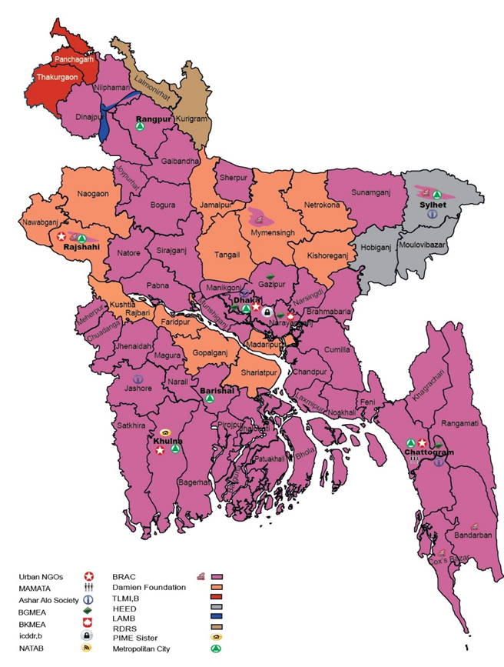

Multiple NGOs receive funding as SRs under the current GFATM grant and have signed an MoU with NTP for service delivery. These SRs will continue work under PR2 and will be managed by PR2 as in the past by signing a sub-agreement and following SR management manuals and guidelines. PR-2 coordinates with the SRs through an annual planning workshop and quarterly performance review meetings.

- Describe key, anticipated implementation risks that might negatively affect (i) the delivery of the program objectives supported by the Global Fund and/or (ii) the broader health system. Then, describe the mitigation measures that address these risks, and which entity would be responsible for these mitigation measures.

Key Implementation Risks | Corresponding Mitigation Measures | Entity Responsible
Programmatic and performance risks:  - Unstable funding situation. This risk is considered to be of high likelihood and high impact.  - Low MIS database sustainability. This risk is considered to be of low likelihood and low impact.  - High staff turnover rates. This risk is considered to be of medium likelihood and medium impact. | The remedial measures taken by the PR will focus on further resource mobilization from currently involved funding sources, i.e. GOB and USAID, and additional resource mobilization from additional donors to be identified.  The remedial measures employed include further software development and intensified training on data management.  The remedial measures seek to reduce job dissatisfaction to improve retention rates. | NTP
Fiduciary and financial risks:  - Risks resulting from fluctuating foreign exchange rates. This risk is considered to be of low likelihood but high impact for the program.  - Market price changes for procurement items. This risk is considered to be of medium likelihood and high impact.  - General risks related to the procurement process. These risks are considered to be of medium likelihood and medium impact. | The remedial measures employed include the reallocation of funds between different funding sources, and the general strengthening of the use of internal sources for funding.  Remedial measures employed include the reallocation of funds between different funding sources, the general strengthening of the use of internal sources for funding, and the bulk purchase of procurement items.  The remedial measures employed include the attention to value for money during the procurement process and the utilization of an open, competitive and transparent procurement system. | NTP
Health services and health product quality:  - Risks resulting from natural calamities. These risks are considered to be of medium likelihood and high impact for the program.  - Risk related to the use of LMIS. These risks are considered to be of medium likelihood and of low impact for the program.  - Risks for drug quality resulting from interruptions to power supplies. These risks are considered to be of medium likelihood of medium impact. | Remedial measures include the strengthening of emergency preparedness procedures, and the provision of adequate buffer stocks for procurement items.  Remedial measures include further software development and intensified training on data management.  The remedial measure employed is the provision of power generators for backup during power blackout periods. | NTP
Governance, oversight and management:  - Risks resulting from the interruption or termination of currently existing partnerships. This risk is considered to be of low likelihood and of high impact for the program.  - Risks related to insufficient oversight by technical experts. This risk is considered to be of low likelihood and of high impact. Risks related to internal control mechanisms. These risks are considered to be of low likelihood and of high impact. | The remedial measure employed is a further development of partnership structures, following the model used for PPM activities.  The remedial measures employed include the strengthening of the CCM oversight mechanism, the establishment of a CCM committee focusing on technical oversight requirements, and the clear description of requirements for technical assistance in a technical assistance plan to be developed by the technical committee.  The remedial measures employed include the further development of the existing internal control system. | NTP
Add rows as needed

Section 4: Co-Financing, Sustainability and Transition

To respond to the questions below, refer to the Instructions, the domestic financing section of the allocation letter, the Sustainability, Transition and Co-Financing Guidance Note, Funding Landscape Table(s), Programmatic Gap Tables(s), and a sustainability plan and/or transition work-plan, if available.

Co-Financing

- Have co-financing commitments for the current allocation period been realized?

☒ Yes ☐ No

If yes, attach supporting documentation demonstrating the extent to which co-financing commitments have been met.

If no, explain why and outline the impact of this situation on the program:

[Applicant response]

- Do co-financing commitments for the next allocation period meet minimum requirements to fully access the co-financing incentive?

☒ Yes ☐ No

If details on commitments are available, attach supporting documentation demonstrating the extent to which co-financing commitments have been made.

If co-financing commitments do not meet minimum requirements, explain why.

[Applicant response]

- Summarize the programmatic areas to be supported by domestic co-financing in the next allocation period. In particular:
    - The financing of key program costs of national disease plans and/or health systems;
    - The planned uptake of interventions currently funded by the Global Fund.

During previous funding cycles, the GF has engaged in Intensified discussions with the MOH about increased counterpart financing for essential program components. An important result of these discussions has been a commitment by the MOH to fully finance the procurement of FLDs starting in 2018, which will be continued during the next funding cycle. This In addition, MOH will fully cover the following components of the NSP with a total budget of USD 172 Million During the grant implementation period 2021-2023:
- Procurement of X-ray machines
- Procurement of Refrigerators
- Laboratoy consumables- X-ray Films
- Laboratoy consumables- Glass Slides
- Laboratoy consumables- Sputum cups
- Laboratoy consumables- Syringes
- Laboratoy consumables- Other supply & Services
- Laboratoy consumables- MT Test Kits
- Salary of MOH Officers at all levels of the NTP
- Training of staff at peripheral levels
- Procurement of First Line Drug (FLD)
- Procurement of First Line Loose Drug
- Procurement of Ancilliary Drugs
- Maintenance of Vehicles
- Vehicle fuel and gas
- Vehicle registration fees
- Procurement of motor vehicles
- Office equipment
- Telecommunications equipment
- Furniture, fixurest and other supplies
- Second line LPA (two additional facilities)
- Repair & maintenance of machines/ laboratory equipment
- Publishing of NTP guidelines and SOPs
Due to the significant increase of MOH funding for TB, the overall MOH contribution to the NSP funding requirements will reach 32.4% during the 2021-2023 period. The most significant contribution of MOH funding will be in the area of TB treatment, where 100% of the required funding will be covered due to the MOH commitment to fully cover the funding of first line drug requirements.

- Specify how co-financing commitments will be tracked and reported. If public financial management systems and/or expenditure tracking mechanisms require strengthening and/or institutionalization, indicate how this funding request will address these needs.

Co-financing commitments will be tracked through the MOH’s financial management systems and reported in the MOH’s annual financial reports.

Sustainability and Transition

    - Based on the analysis in the Funding Landscape Table(s), describe the funding need and anticipated funding, highlighting gaps for major program areas in the next allocation period.

Also, describe how (i) national authorities will work to secure additional funding or new sources of funding, and/or (ii) pursue efficiencies to ensure sufficient support for key interventions, particularly those currently funded by the Global Fund.

The total NSP funding requirements to achieve the target of >90% CDR by 2023 are USD 530 million over the three-year period covered under the current funding proposal (2021-2023). The GOB funding contribution is expected to be USD 172 Million, and USAID support is expected to be around USD 26 Million.As a result of the prioritization of increasing case detection, NSP activities linked to the NSP strategic area “Increase annual case detection of all forms of TB to more than 90% of all incident cases”requires a funding amount that significantly exceeds all other components of the NSP. As shown in the graph below, a significant funding gap remains for this area after expected contributions by the MOH and USAID are taken into account.
NSP funding requirements and funding gaps by NSP objective
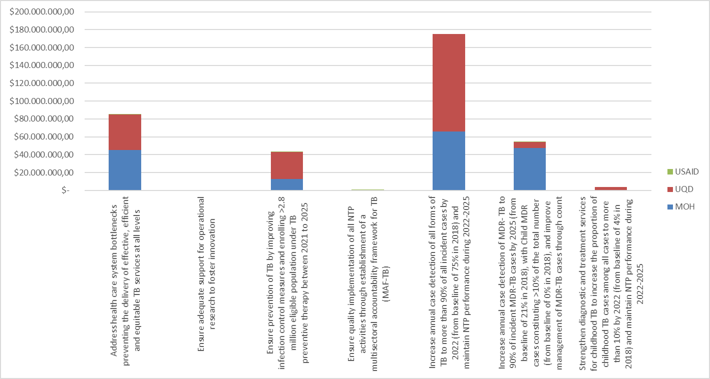

The MOHFW is aiming to achieve efficiency gains through improved budget management and fund absorption capacity (average 90%), which in turn can yield some additional financial resources.

8th JMM stated that, there is a lack of clarity on the financial needs for the TB response. The budget estimates for the TB –NSP are out of date and do not reflect current needs such as enhanced case finding in key population, scaling up of molecular testing and digital x-ray for TB diagnosis, preventive therapy and appears to be a perception that TB is “already being funded”, therefore domestic resources shifted away to other programs. Even when the funding from GoB is available administrative bottlenecks in fund disbursement have the potential to derail implementation of intervention. It also recommended to develop a robust and ambitious TB-NSP as primary advocacy tool (the investment case) and continue periodic review of financial availability and gaps taking into account the need to scale up of intervention.
a) Organize Quarterly Financial Workshop to review the Financial Performance, future planning and cost sharing plan.
This activity will allow NTP to sustain an efficient financial capacity within NTP which will contribute to deliver efficiently and to identify resource gaps considering updated TB –NSP ( 2021-2025 ) , TBLepASP OP in 4th HPNSP and to prioritize allocation for 5th HPNSP.
b) Prepare high-level Policy Brief on TB Funding Gaps and mapping of available funding sources for high level advocacy on TB Funding .
NTP prioritizing the high level policy advocacy for TB and addressing Multi accountability Framework. A periodic fact sheet on TB will be prepared as policy brief (investment case) to urge and nudge the GoB to increase more financing for TB.
c) Conduct TB patient Cost Survey
To measure progress towards high- level end TB Strategy target, WHO recommends baseline and periodic measurement using an indicator termed “ catastrophic total costs due to TB’’. Measurement is based on the conduct of survey examining the costs to patients associated with TB, and can enable the estimation of the proportion of patients experiencing catastrophic costs, these are referred to as “TB patient cost survey’’. NTP already developed the protocol for conducting “TB patient cost survey’’ and planned to implement the survey. Survey findings can be used to monitor financial access barriers and inform related health and policy changes to improve TB prevention and care.
d) Organize Workshop to revise and update fully costed NSP
NTP Strategic Plan 2021-2025 will be reviewed and updated in 2025 to develop a prioritized list of interventions at the scale that is needed to end TB. For this, robust consultative workshop to develop fully costed NSP to define as much as possible the choices that will be made in various funding scenarios , by for example, indicating which interventions will be implemented if 100%, 75% 50% etc. of the resources needed to implement the TB-NSP are mobilized.
e) Organize Workshop to develop contingency plan for disaster and climate Change and to ensure uninterrupted TB Services .

    - Highlight challenges related to sustainability (see indicative list in Instructions). Explain how these challenges will be addressed either through this funding request or other means. If already described in the national strategy, sustainability and/or transition plan, and/or other documentation submitted with the funding request, refer to relevant sections of those documents.

Challenges related to sustainability and the NTP’s strategic interventions to address these issues are described in section 8.5. of the NSP, “Address health care system bottlenecks preventing the delivery of effective, efficient and equitable TB services at all levels”.

ANNEX 1: DOCUMENTS CHECKLIST

Annex 1: Documents Checklist

Use the list below to verify the completeness of your application package.

☐ | Funding Request Form
☐ | Programmatic Gap Table(s)
☐ | Funding Landscape Table(s)
☐ | Performance Framework
☐ | Budget
☐ | Prioritized above allocation request (PAAR)
☐ | Implementation Arrangement Map(s)
☐ | Essential Data Table(s) (updated)
☐ | CCM Endorsement of Funding Request
☐ | CCM Statement of Compliance
☐ | Supporting documentation to confirm meeting co-financing requirements for current allocation period
☐ | Supporting documentation for co-financing commitments for next allocation period
☐ | Transition Readiness Assessment (if available)
☐ | National Strategic Plans (Health Sector and Disease specific)
☐ | All supporting documentation referenced in the funding request
☐ | Health Product Management Tool (if applicable)
☐ | List of Abbreviations and Annexes

PAARs can only be submitted with the Funding Request. To complete a PAAR, fill-in the Excel template that you will receive from the Global Fund Secretariat.
This is only relevant for applicants with designated matching funds as indicated in the allocation letter.
Latent tuberculosis infection: updated and consolidated guidelines for programmatic management, WHO/CDS/TB/2018.4
Strategies for ending tuberculosis in the South-East Asian Region: A modelling approach. Indian J Med Res 149, April 2019, pp 517-527
An updated implementation arrangement map is mandatory if the program is continuing with the same PR(s). In cases where the PR is changing, the implementation arrangement map may be submitted at the grant-making stage.
Note that information derived from the supporting documentation provided in response to the questions below, including information on funding landscape or domestic commitments, may be made publicly available by the Global Fund.
An updated implementation arrangement map is mandatory if the program is continuing with the same PR(s). In cases where the PR is changing, the implementation arrangement map may be submitted at the grant-making stage.

