Terms of Reference
  - National consultant to support Country Coordinating Mechanism _Mapping and Positioning
Updated: August 2022 by BCCM
Context | The Global Fund’s Country Coordinating Mechanism (CCM) Policy outlines that the CCM should be positioned at the highest level responsible for multi-partner and multi-sectorial development planning in a country. The Global Fund encourages all countries to build on their national structures, wherever possible, and to position the CCM and/or CCM functions within existing health platforms to contribute to central coordination of health programs, investments and pandemic preparedness. In countries actively preparing for transitioning away from Global Fund financing for at least one disease component, positioning planning and implementation may imply more urgent timelines. These two points should be used to adapt the role of the CCM to support a successful transition process and to promote increased sustainability. This can include gradually shifting essential CCM functions and principles to national health institutions as early as possible for proactive transition planning, rather than waiting for a transition grant. Mapping existing health governance bodies in a country is the first step towards institutionalizing CCM functions.
Scope/  Objective | The national consultant will identify existing national health structures, governance mechanisms and platforms responsible for coordinating the health sector and disease-specific issues. For the transition context, this should have an added focus on key national stakeholders that are most appropriate for strengthening transition planning, preparedness, implementation, and overall efforts to strengthen sustainability.  The consultant will map each identified platform’s position within the national systems and in relation to the CCM. The consultant will also support the CCM in developing a Positioning plan based on three main phases (refer to the Positioning Guidance Note):  - Knowledge  - Coordination  - Sustainable Structure.
Tasks and Metrics | The national consultant is expected to perform the following tasks:  Task Metric  Understand and become familiar with the principle of Positioning. For the transition context, understand the transition lens and how it fits within Positioning. Positioning e-Learning module and review of Positioning Guidance Note completed.  Undertake a desk review of relevant documents. - Governance documents of up to 10 health governance bodies reviewed (CCM included). - When available, Sustainability and Transition assessment reviewed.  Interview key stakeholders at the national level. At least one stakeholder per governance body interviewed, including one high-level government official.  Map existing national health structures. Organigram showing the positions and relations of up to 10 health governance bodies (CCM included). The organigram can be completed manually or using a software solution provided by the Global Fund (Visio).  Develop a summary report. Report drafted (2-4 pages) with thematic tables and analysis on: - Mandate - Composition - Structure - Legal Status - Anchorage level to the national system.  Organize an in-country consultation meeting. - Presentation on key results. - Moderated sessions on the following phases of the CCM Positioning journey: Coordination, Sustainable Structure. The consultation should bring together stakeholders on coordinating and aligning platforms and include the civil society voice.  Support the CCM Evolution Task Force, CCM Executive Committee and CCM Secretariat to develop a CCM Positioning plan. Proposal developed on the appropriate positioning of the CCM. It should include: - Necessary linkages and alignment with other significant coordinating platforms in-country. For the transition context, this includes identifying key national stakeholders, including non-CCM members, that can support national transition planning and implementation, and overall efforts to strengthen sustainability. - Long-term embedment of CCM functions within existing or emerging health platforms, including ensuring strong inclusion of civil society and participating in efforts to strengthen sustainability of Global Fund investments.
Deliverables | Deliverable Content Level of effort (LoE)  Mapping of existing national health platforms. The map should show the national structures and their relationship within the national health sector. 15 LoE  Brief summary report (2-4 pages). An executive summary of key findings, conclusions, options and next steps (including activities for inclusion in baseline assessment work plan – optional based on country context). 2 LoE  Power Point Presentation. Key findings and conclusions from the mapping exercise. 1 LoE  Positioning plan. Plan with cleared outlined deliverables, steps and timeline. 7 LoE  Engagement Plan A plan how to engage the constituencies and national structures in the CCM and Global Fund Governance effectively 7 LoE  Power Point Presentation. Engagement Plan in CCM of all constituency to make effective decisions and oversight GF Grants 1 LoE  Related Work In accordance of Guidance from BCCM Oversight Committee 5 LoE  Time sheet Timesheet must be submitted monthly
Reporting Lines | - The consultant will report to the Chair of BCCM Oversight Committee and the Chair of the CCM Evolution Task Force. All deliverables will submit to BCCM Secretariat.  The consultant will work in close collaboration with the BCCM Secretariat and the BCCM Evolution Task Force.  The BCCM Secretariat is requested to share the consultant’s deliverables with the Global Fund while consultant submitted final deliverables to BCCM Secretariat and BCCM Oversight Committee.
Level of effort and period of performance | The consultant has 48 LoE to be used over a period of 6 months.
Annexes | Annex 1: Example of Positioning map (designed with software Visio).  Annex 2: Example of Positioning map (manually built).

Candidate Profile | A. Qualifications  Essential:  Minimum Master Degree in Social Sciences with Master’s in Public Health; or MBBS with Master’s in Public Health.  B. Experience  Essential:  - At least 10 years of experience in Public Health project. Minimum 5 years of working experience in Health Governance in leading managerial position in National and/or International Organizations, UN Agencies, Bilateral Organizations. Experience in national-level project planning, monitoring, evaluation related to TB, Malaria and HIV programs; Global Fund Grants implementation and oversight will be of added value.  - Knowledge on epidemiological and programmatic indicators for, HIV, TB, Malaria and COVID-19 and key financial indicators.  - Experience in public health and disease program management with focus on HIV and AIDS, tuberculosis and malaria.  - Working experiences with Bangladesh Government specially with Ministry of Health and Family Welfare and/ or departments or projects under this Ministry  - Solid experience in developing partnerships in political environments and in mediating complex issues and deliverables at country, regional and international levels.  - Rich professional experience, including a track record of working in strategy and policy analysis, program planning and management, and/or equivalent experience.  - Solid understanding and experience of strategic, organizational, financial and management issues.  - Solid understanding of the Global Fund processes and of its funding model.  - Excellent written and verbal communication skills in Bangla and English.  Desirable:  - Professional experience (international or national) working in planning and management in the humanitarian sector.  - Documented experience of coordination across multiple stakeholders.  C. Competencies  Languages:  Proficiency in English and Bangla as local language (particularly the one most widely spoken by key population representatives) are a requirement for this role.  Technical skills:  - Proficiency in Microsoft Office applications especially Excel/ Access, email, internet and websites essential.  - Robust understanding of governance matters.  - High degree of organization, initiative and political awareness.  - Knowledge of public health issues.  - Strong interpersonal skills and proven ability to communicate and interact with high-level officials from the government, NGOs, UN agencies and the private sector.  - Strong writing, presentation and communication skills and IT competences are essential.  - Ability to lead a team and set priorities while handling multiple tasks simultaneously.  - Previous development experience and/or background with government or private sector desirable.  - Proficiency in data collection, triangulation and information analysis from different sources.  - Proficiency in the use of Microsoft Office, particularly Microsoft Word, Power Point and Microsoft Excel  - Knowledge of the software Visio will be added value  - Ability to work effectively with staff and organizational stakeholders.  - Ability to set priorities and work independently as well as part of a team.  - Proficiency in English and Bangla typing is required.  - Fluency in spoken and written English and Bangla.  Age Limit: 45 to 65 years  Consultancy Fees: USD 5,200 for Mapping and USD 4,800 for Positioning (To be paid in BDT as per average conversion rate bank transfers to BCCM Bank account during 2022). Payment will be made based on submission of deliverables divided into six months of assignment. Tax and VAT will be deducted as per government rule.  How to apply: Application needs to be sent to bccmsecretariat@gmail.com with a cover letter (describing candidate’s suitability and potential in contribution to the position), detailed CV, recent photograph, and scanned copies of educational certificates, experience certificates and NID. Incomplete application will NOT be considered. Detailed vacancy notice of this post is available at: bccmbd.org. Application deadline is 03 May, 2023.The BCCM Recruitment Committee reserved all rights to make any decision for this recruitment. Only short-listed candidates will be called for the written test and further process.

Annex 1: Example of Positioning Map (Designed with Visio Software)
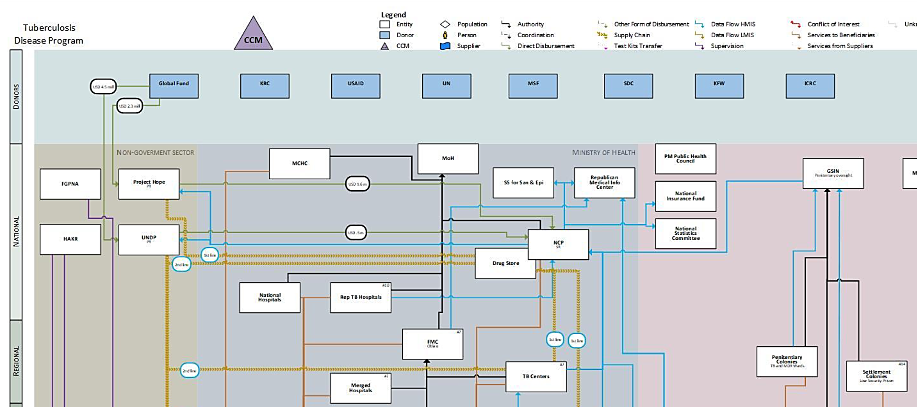

Annex 2: Example of Positioning Map (Manually Built)
Prime Minister’s Office
CNLS (NAC)

National Health Sector Coordinating Committee (HSCC)
(multisectoral)
Emergency Response Coordination Body

Formal linkage
Informal linkage for communication and collaboration
CCM Sub-Committees
Ministry of Health
CCM
National Disease Programs
Ministry of Budget
HSCC Technical Secretariat

GAVI committee
Department of Planning and
Cooperation

Countries will be informed if they are in the transition context

